Design Aspects:

-Font: Arial

-Font Sizes: 14, 20 (bold)

-Colours:

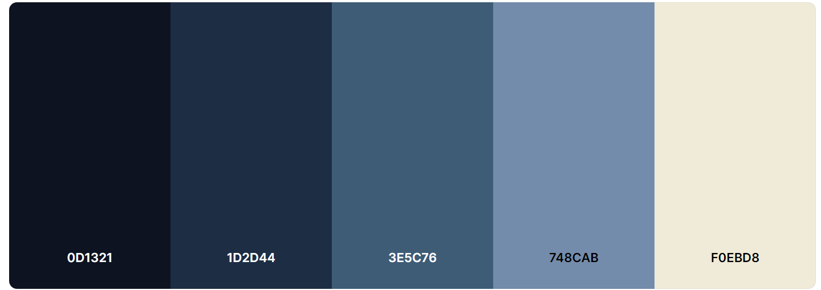

Primary Colour: #3E5C76

Secondary: #1D2D44

(Third): #748CAB

If unsure, use a neutral colour like #0D1321 or #F0EBD8.

Adding CSS to fxml file:

[Styling JavaFX applications using CSS | CalliCoder](https://www.callicoder.com/javafx-css-tutorial/)

Digital Tracking:

[Health and Performance Monitoring for Java Applications | MoSKito](https://www.moskito.org/)